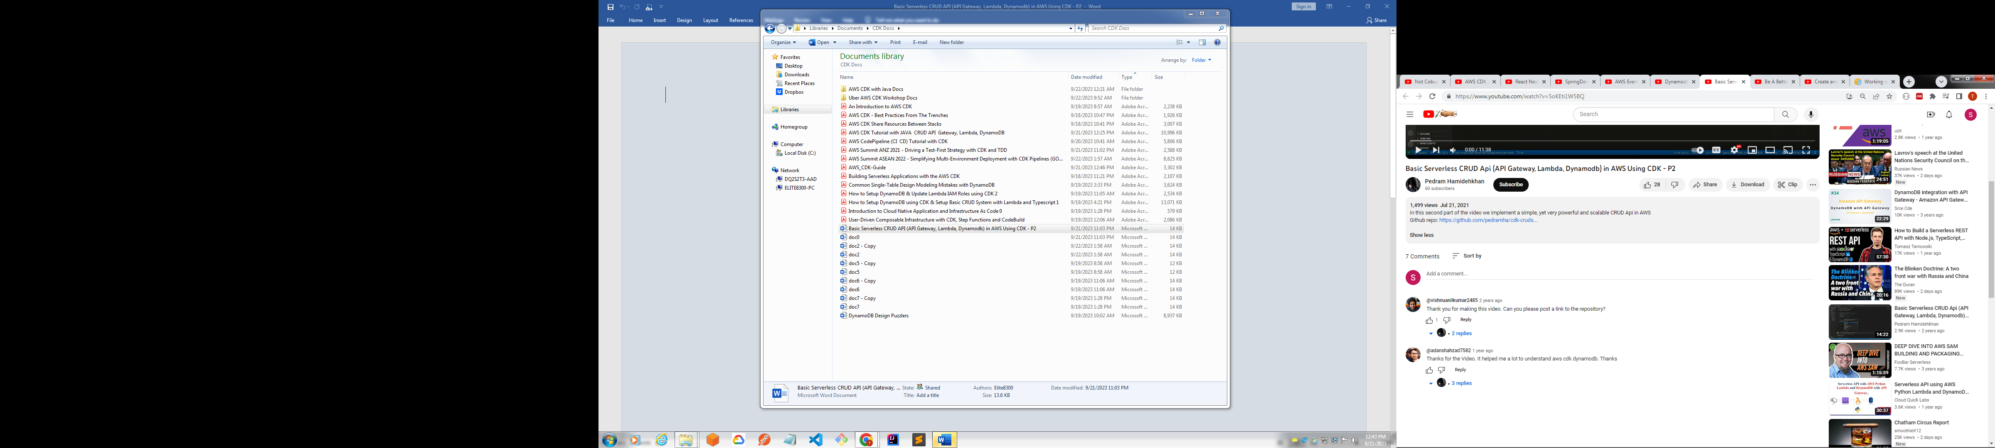

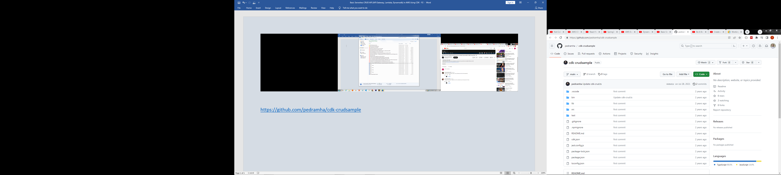

<https://github.com/pedramha/cdk-crudsample>

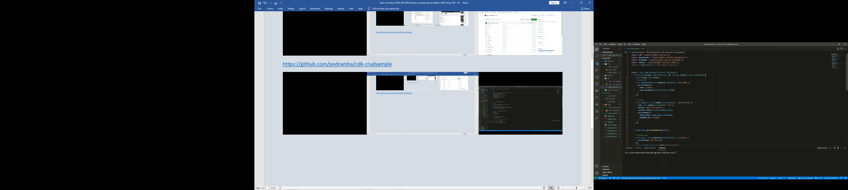

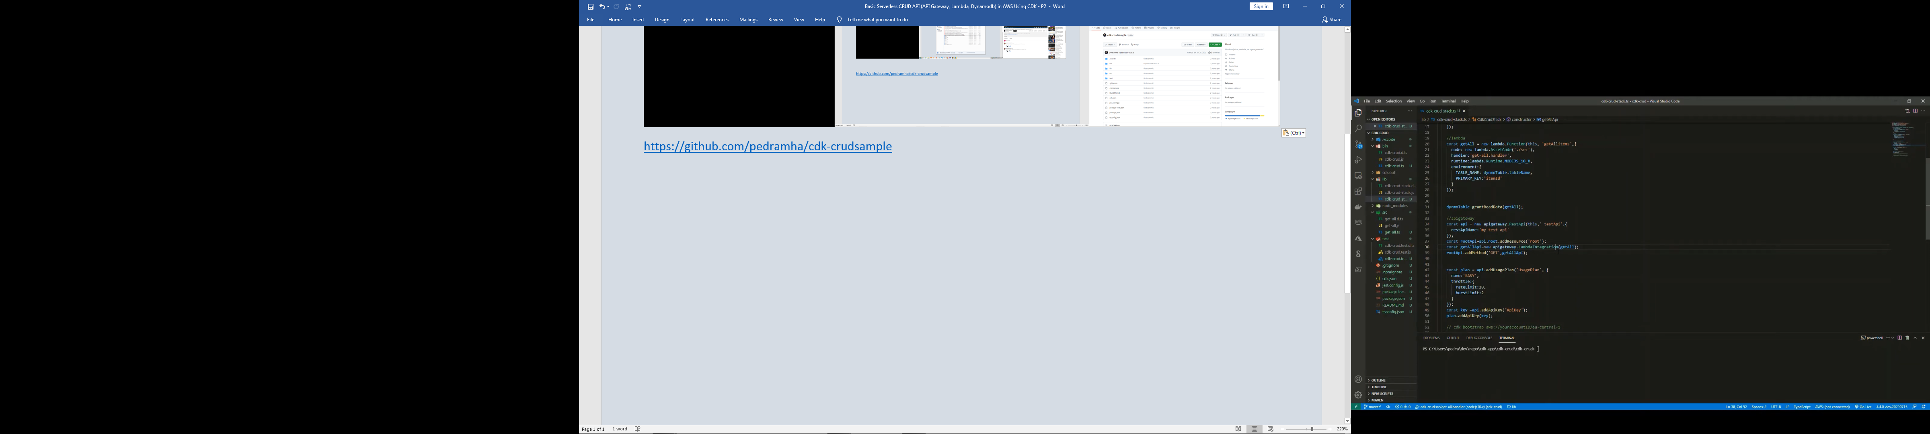

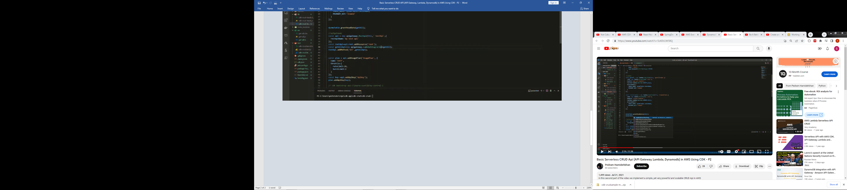

2.19